ECE423 Homework 3

Jing Guang Sia

Sihe Yang

1. Based on hand derivations from paper, the following transfer function:

$$H\left(s\right)=\frac{g_{m1}*R_{1}*g_{m2}*R_{2}*(1-sC_{c}(\frac{1}{g_{m2}}-R_{z}))}{\left(1+\frac{s}{p_{1}}\right)*(1+\frac{s}{p_{2}})}$$

has the following Bode Plot(at Rz=0).

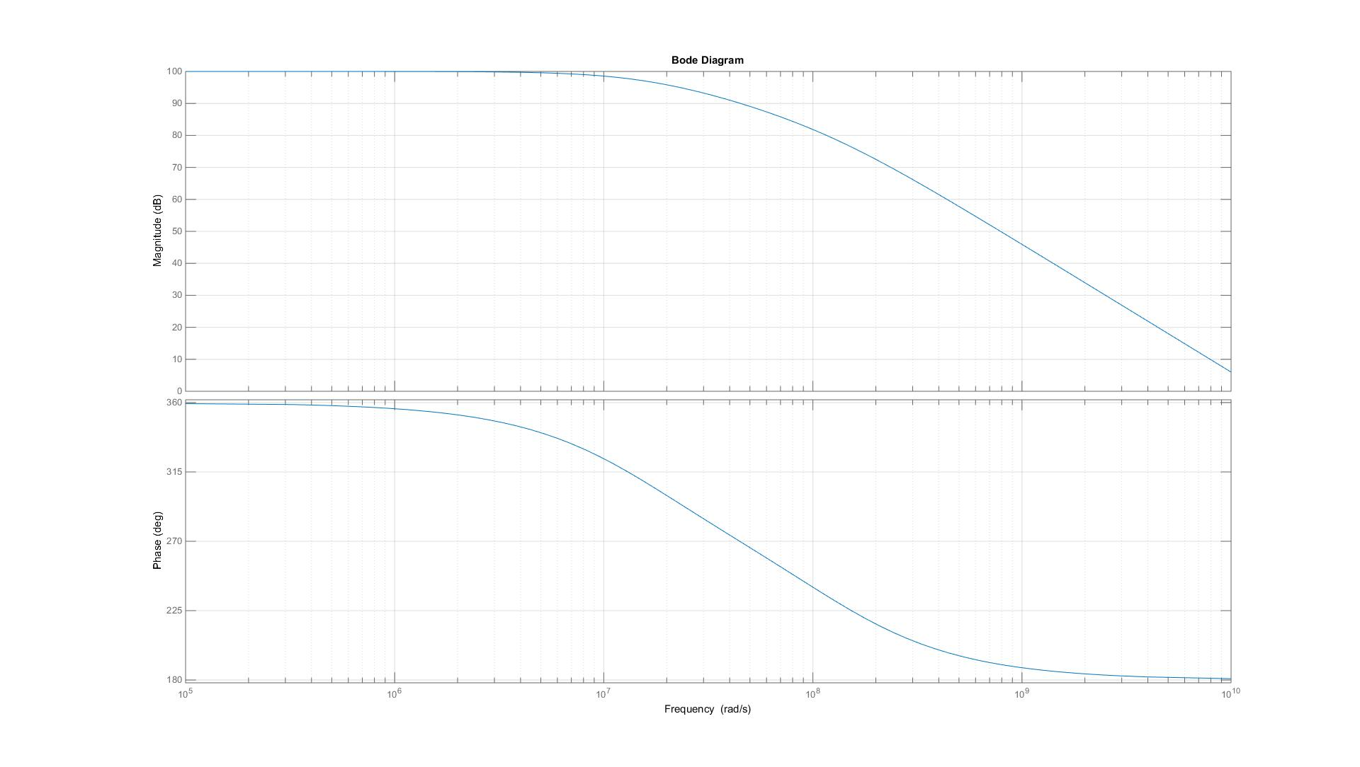

Figure 1. Bode Plot of Transfer Function with no Nulling Resistor

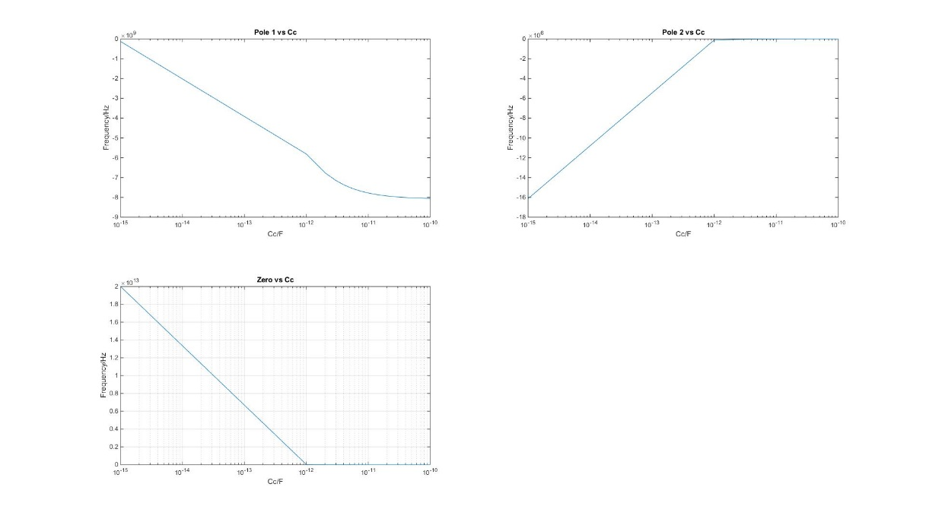

Figure 2. Pole and Zero Behaviors versus Miller Compensation

Pole 1 increases as the compensation capacitance increases, while pole 2 decreases as the capacitance increases. This is consistent with the theory of pole splitting, where the dominant pole (P2) is separated from the next pole (P1) as C­c increases. In addition, the zero seems to decrease when CC increases, although this is not relevant. All the poles graphed are negative. On the complex plane, this puts the poles on the LHP. Such a result is desirable, as RHP poles do not give stable circuits.

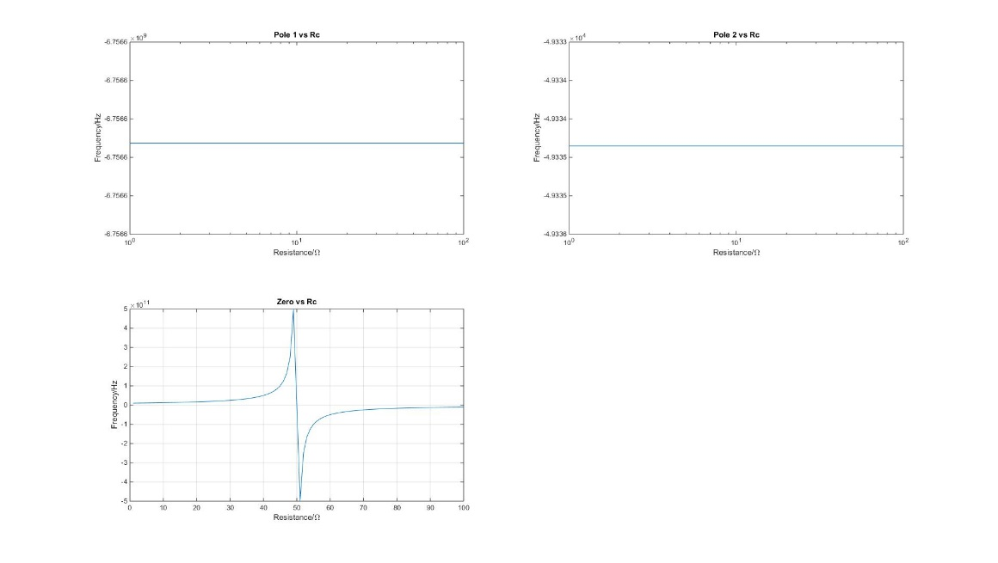

Figure 3. Pole and Zero Behaviors versus Nulling Resistance

Adding the nulling resistor does not affect the pole, as it serves to eliminate the undesirable zero. When RC is 50 ohms, the zero is completely eliminated. In theory, there should be a discontinuity at 50 ohms. However, due to limitations with MATLAB, this is not shown. It should be noted that when the null resistance is equal to Rds of second stage, zeroes can be eliminated, not just reduced.

1. The transfer function to analyze is $H\left(s\right)=\frac{{10}^{3}}{\left(1+\frac{s}{{10}^{3}}\right)\left(1+\frac{s}{{10}^{5}}\right)\left(1+\frac{s}{{10}^{6}}\right)+{10}^{3}}$.

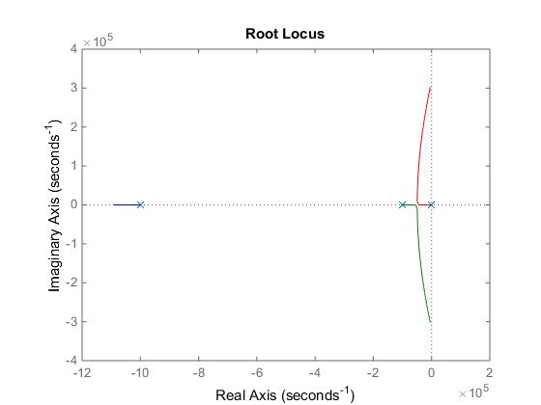

Figure 4. Root Locus Analysis of three pole transfer function

When feedback is 0, all poles lie on the real plane. As feedback begins to increase, the poles will move along the planes. The dominant pole moves in a leftwards direction along the real plane. The second pole moves right and upwards, and the third pole moves right and downwards in the plot. Notice how all the poles are on the LHS: this indicates a stable system.

$H\left(s\right)=\frac{{10}^{6}}{\left(1+\frac{s}{1}\right)*\left(1+\frac{s}{p_{2}}\right)+{10}^{6}}$

Sweeping a large range of P2 to find the phase margin is undesirable, as it can take a really long time. To find pole 2 faster, we can use the **margin** function in MATLAB iteratively until we find a suitable range to sweep P2. A frequency of 10kHz gives a phase margin of 25.8, and at a frequency of 100kHz the phase margin is 90. This range is suitable for the phase margin range we work with. Another calculation to find the pole frequency for 40 to 80 degrees further narrowed the sweeping range, from $2*{10}^{5}Hz$ to $9*{10}^{5}Hz$.

Below are the data collected for the opamp.

|  |  |  |  |
| --- | --- | --- | --- |
| Phase Margin | p2/a0p1 | Overshoot | dB Peak |
| 40 | 0.234 | 45.6985 | 1.4570 |
| 45 | 0.293 | 41.3252 | 1.4133 |
| 50 | 0.358 | 37.2776 | 1.3728 |
| 55 | 0.427 | 33.6974 | 1.3370 |
| 60 | 0.500 | 30.4890 | 1.3049 |
| 65 | 0.577 | 27.5315 | 1.2753 |
| 70 | 0.658 | 24.7965 | 1.2480 |
| 75 | 0.742 | 22.3047 | 1.2230 |
| 80 | 0.827 | 20.1087 | 1.2011 |

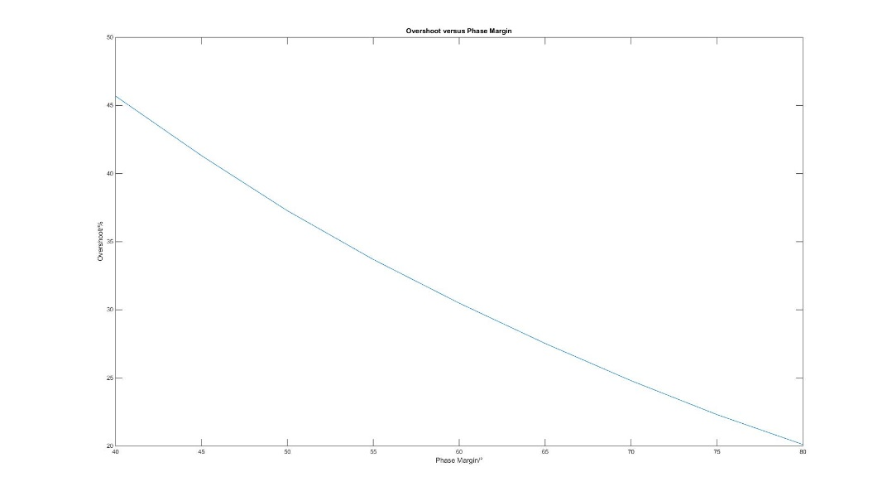

Figure 5. Overshoot versus Phase Margin

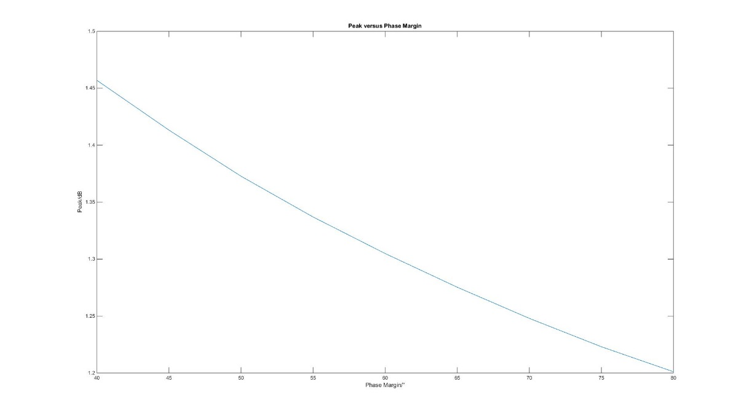

Figure 6. Peak dB versus Phase Margin

A higher phase margin gives a lower phase margin and peak magnitude gain, which gives a more stable circuit.

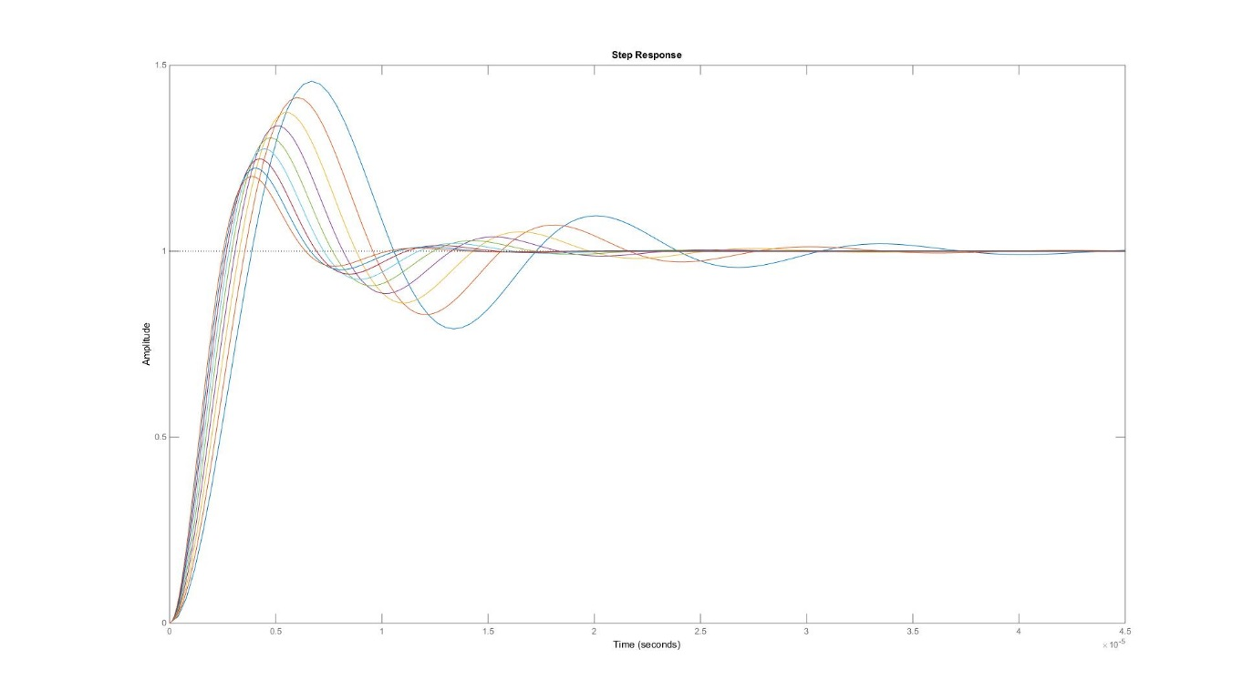

Figure 7. Step Response of the opamp

1. The open loop gain decreased to 102 while the first pole increased to 104.  Doing so decreases the phase margin and overshoot by a little bit, compared to those found in problem 3.

|  |  |  |  |
| --- | --- | --- | --- |
| Phase Margin | p2/a0p1 | Overshoot | dB Peak |
| 40 | 0.234 | 44.2152 | 1.4279 |
| 45 | 0.293 | 40.1877 | 1.3880 |
| 50 | 0.358 | 36.4288 | 1.3508 |
| 55 | 0.427 | 33.0066 | 1.3169 |
| 60 | 0.500 | 29.8743 | 1.2859 |
| 65 | 0.577 | 26.9918 | 1.2573 |
| 70 | 0.658 | 24.3703 | 1.2314 |
| 75 | 0.742 | 21.9827 | 1.2077 |
| 80 | 0.827 | 19.8237 | 1.1864 |

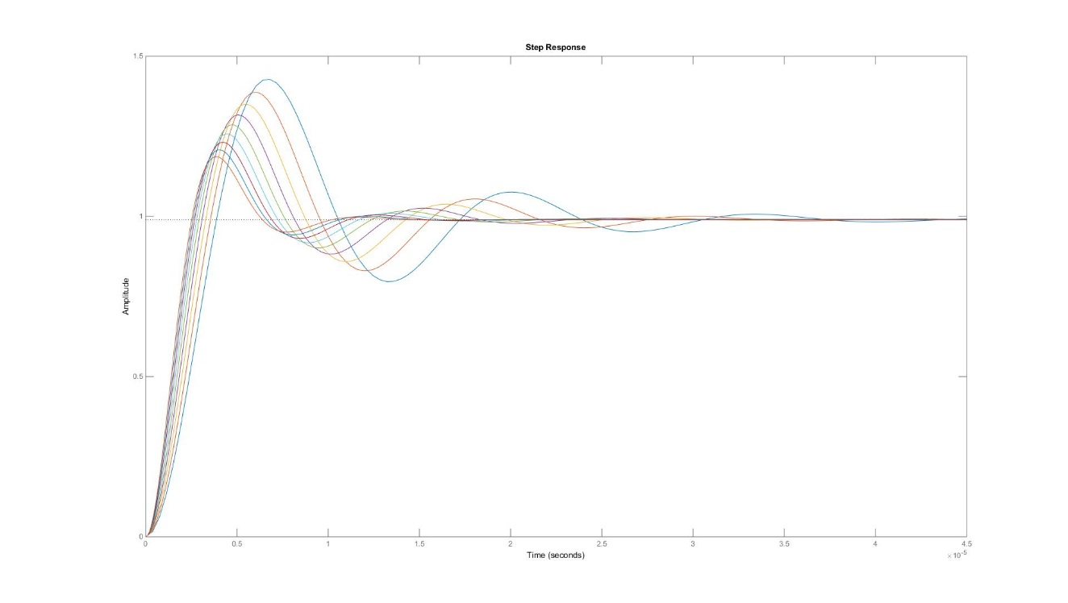

Figure 8. Step Response of the opamp, with higher dominant pole and lower open-loop gain.

A dominant pole that is bigger is further away in the LHP of the s-plane diagram. The further away the poles are from the RHP, the more stable it is. A more stable opamp would have a feedback response that dies out quickly, hence giving a lower overshoot and overshoot peak.